Student’s name | …………………………………………………….…… | Grade | 3
Subject | Computer | Week No. | 8
Lesson Title | Page Design | Unit
Worksheet No. ( 8 ) (Answer)

Question A: Write the correct name of each part.

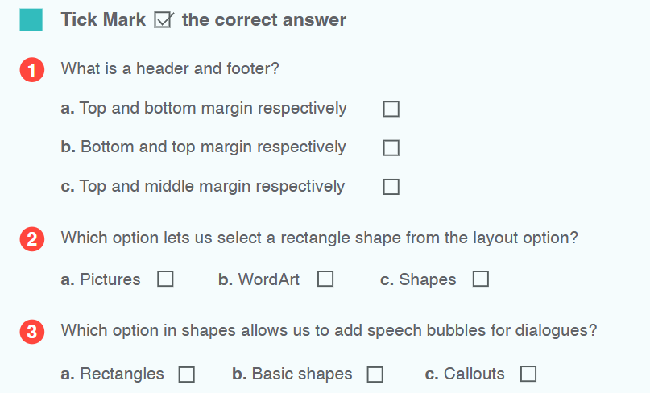
✔️
✔️
✔️
Good Luck

